Background:
When taking medicine, even simple pain relievers like ibuprofen, dosage plays an important role. The dosage ensures that there will be enough medicine to treat a person’s symptoms but will be low enough to prevent a toxic concentration (concentration is the amount of medication dissolved in the blood). This is why pain relievers specify adult doses and children’s doses: to account for the difference in size and, therefore, blood volume.
Outside of drug development, concentrations play a big role in hands-on lab research. In the lab, if the concentration is too low, you might not be able to get the expected product. Regardless of the scenario, concentration helps us to communicate what a solution is composed of. There are many ways to communicate this: molarity (M), molality (m), percent volume, percent weight, or even just a comparative value, like 10X or 1X.
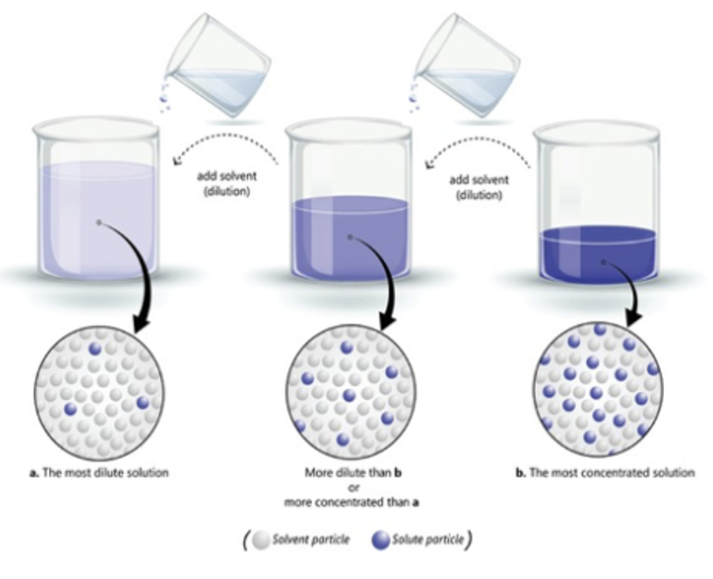
Often in science, solutions and reagents are provided as a concentrated stock. This means that there is a lot of reagent present, probably too much. Concentrated stock solutions have high amounts of reagents compared to the amount of water or solvent present but can be diluted to various weaker concentrations needed in the lab. By diluting, we add more water or solvent to weaken the solution’s concentration, similar to adding water to concentrated juice to make it less strong.
It is much easier to dilute a substance than it is to concentrate.
To determine how much stock solution to use, scientists use the following equation:
C₁ V₁ = C₂ V₂
C₁ = concentration of the stock solution
V₁ = volume of the stock solution needed
C₂ = the concentration of the needed solution
V₂ = the total volume of the needed solution.

This is most frequently used to determine how much stock to use in our experiment (V₁) or when we need to determine the final concentration of a solution (C₂).
In this lab, you will practice diluting stock samples of fluorescein and calculating concentrations by performing a serial dilution. Serial dilutions generally decrease concentration by five-fold or tenfold from tube to tube. Today we will do a five-fold dilution.
Materials:

- Micropipette (p50)
- Micropipette tips (5-200 µL)
- P51 Viewer
- Permanent Marker
- 1mL dH₂O
- Five 0.2mL microcentrifuge tubes
- 500 µL 40 µM fluorescein

Procedure
- Label the provided 0.2 mL microcentrifuge tubes, 1-5.
- With the micropipette, add 40 µL of 40 µM fluorescein to tube 1.
- Add 10 µL of 40 µM fluorescein to tube 2.
- With a new pipette tip, add 40 µL of water to tube 2. Pipette up and down to mix.
- Use the equation, C₁ V₁ = C₂ V₂ to calculate the concentration of fluorescein in tube 2. Record it in the data table on the following page.

C₁ = Concentration of the solution you are adding
V₁ = Volume of solution you are adding
C₂ = Concentration of final solution in new tube (i.e. what you are solving for)
V₂ = Total volume of final solution in new tube

- Place tubes 1 and 2 into the tube rack in the P51 viewer and close the cover, velcroing both sides down. Then turn on the blue light with the switch at the back of the device.

Experiment Check
Fluorescein is a fluorophore, meaning that it is fluorescent when exposed to short light wavelengths. For fluorescein, when exposed to blue light (494 nm), it fluoresces yellow/green (512 nm). With less of a fluorophore present, the fluorescence intensity should decrease. How does the fluorescence of your tubes compare?
_____________________________________________________________________________________________________________________________________________________________________________________________________________________________________________________________________________________________________________________________________________________________________________________________________________________________________________________________________________________________________________________

- Transfer 10 µL of liquid from tube 2 to tube 3.
- With a new pipette tip, add 40 µL of water to tube 3.
Pipette up and down to mix.

- Use the equation from the previous page to calculate the concentration of fluorescein in tube 3. Record it in the data table.
- Transfer 10 µL of liquid from tube 3 to tube 4.
- With a new pipette tip, add 40 µL of water to tube 4. Pipette up and down to mix.
- Use the equation from the previous page to calculate the concentration of fluorescein in tube 4. Record this in the table below.
- Transfer 10 µL of liquid from tube 4 to tube 5.
- With a new pipette tip, add 40 µL of water to tube 5. Pipette up and down to mix.
- Use the equation from the previous page to calculate the concentration of fluorescein in tube 5. Record this in the table below.
- Place all your tubes in the P51 viewer in order 1-5. Turn on the light.

Tube | Calculations (C₁ V₁ = C₂ V₂) | Concentration of fluorescein
1 | n/a | 40 mM
2
3
4
5

Accuracy Check:
Look at your samples. The fluorescence of your sample should decrease by a fifth for each concentration. Identify 2-3 parts of the experiment that could have affected your accuracy in getting this result.

