Designing an Experiment:
When we are asking a scientific question, we must ensure that the conclusion we come to at the end of an experiment is valid, replicable, and without bias. We do this before we even start the experiment by ensuring that our experiment is set up correctly. When we are doing experimental research, it is important that we ask the following questions before we ever pick up a pipette.
      - What is the question I am trying to answer?
      - What is my hypothesis?
      - What are my variables?
      - What are my controls?
      - How will I control random variation?
      - What kind of data will I collect?
When the time is put into how we set up an experiment, we can have higher confidence in our results. We will review the essential parts of designing an experiment.
The Question
The first thing one must do is identify what the research question we are asking is. A good scientific question should be specific, testable and have a clear impact.
Hypothesis
A hypothesis is a prediction that you make about what you are studying- a possible answer to your scientific question. It should be written as a clear statement and testable based on the experimental data you are collecting.
Variables
It is important to identify the variables of your experiment to ensure that you can clearly define what you are measuring, what you are controlling, and what things you can’t control. There are 4 major variable types:
- Independent: The variable that you change in your experiment.
- Dependent: The variable that you measure.

- Controlled: The variables that you ensure do not change between samples or between repeat experiments.
- Confounding: The unaccounted-for variables that may differ between samples or repeat experiments, and affect both dependent and independent variables, causing an incorrect interpretation of results (or preventing an interpretation of the results).
Controls
Controls are the baseline of your experiments. The two most common types of controls are positive and negative controls.
- Positive control: A validation control that demonstrates the presence of an effect in order to show that your experiment worked.
- Negative control: A control that demonstrates the absence of an effect to show a baseline readout for the experiment.
Additionally, an experiment could contain internal controls. While positive and negative controls are essential for an experiment overall, internal controls allow for consistency between samples and can help with natural biological variation.
Replicates
Creating replicates in your experiment are essential for controlling random variation. There can be biological variation that is naturally occurring between samples and technical variation caused by the experimenter or equipment. Both of these are unavoidable but can be reduced by adding replicates.
Experimental Approach
This is where we decide how to set up an experiment. When deciding how to approach an experiment we must consider what will provide us with the answer we are looking for but also is feasible. It is always a good approach to do simplest or easiest experiments first. A common approach is to create a sketch or diagram of your experiment with controls, variables, and methods clearly defined. An example from Dr. Neil Robbins of the Carnegie Institute is below:

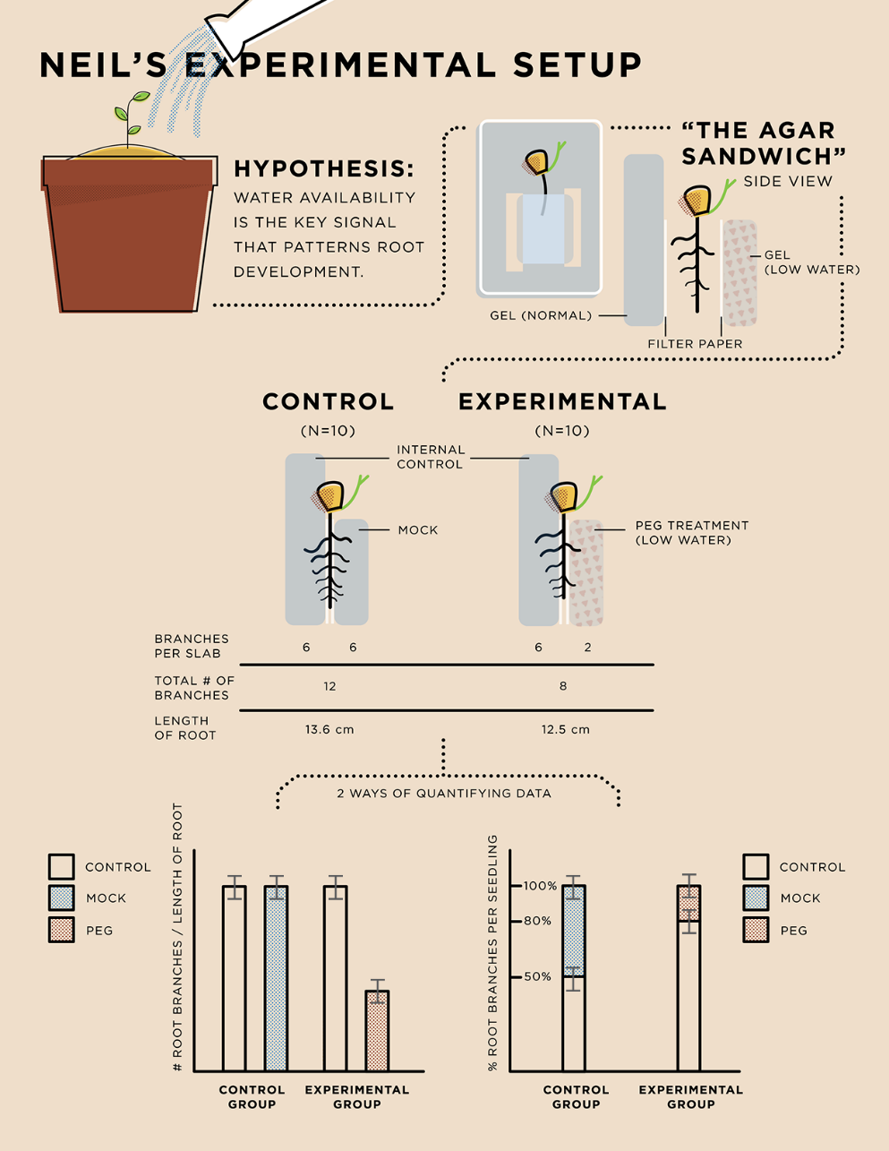
What are the direct and indirect variables in this experiment?

What purpose does the internal control do in this experiment?

How did Dr. Robbins collect and represent data?

What else do you notice about the plan?

Warm Up Activity: Design a Research Experiment

You are tasked to design an experiment to answer a scientific question. You must create a protocol that is replicable, valid, and able to be performed by your peers.

You will have 10 minutes to design your experiment. Your experiment should identify control groups, variables, data you will collect, and possible outcomes.

