Part I: Making a Gel
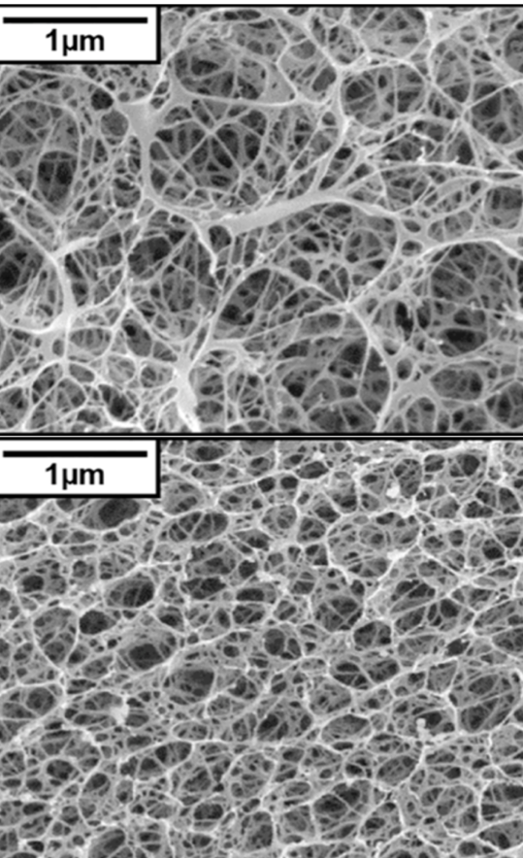
Gel electrophoresis is a laboratory technique used to separate and analyze biological molecules, such as DNA and proteins, based on their size and charge through a gel matrix under an electric field. The gel itself is a semi-solid material, most commonly agarose, that acts like a molecular net, allowing smaller molecules to travel more easily than larger ones. By running samples through a gel, scientists can compare fragment sizes, confirm the presence of specific alleles, evaluate experimental results, and more!
1%
2.9%

Before running a gel, scientists must decide how the gel itself should be prepared because gel composition directly affects how DNA and proteins move and separate during electrophoresis. In this part of the lab, you will design and prepare your own agarose gel rather than following a pre-written recipe. Agarose gels form a three-dimensional molecular matrix whose pore size depends on agarose concentration. Lower-percentage gels, such as 0.8% agarose, create a looser network with larger pores that allow larger DNA fragments or protein complexes to migrate more easily.
Higher-percentage gels, such as 2% agarose, form a denser matrix with smaller pores that slow migration and provide better resolution of smaller DNA fragments or lower molecular weight proteins. In this activity, you will use this molecular understanding to calculate, justify, and prepare a gel that best fits your experimental goals.
GOAL
You will design and prepare a 1% agarose gel by determining the correct amounts of agarose and buffer needed based on your available materials and the number of gels your group plans to pour.

PART I: DETERMINE GEL VOLUME

- How many gels will your group prepare? If you’re not sure, check with your instructor.
1 gel 2 gels
- Using your gel tray, dams, and gel comb, build a complete gel tray. Reference the photo below as needed. Some experiments require an end well gel while others may require a center well gel. Check in with your instructor & your future experiments to decide where to place your gel comb.

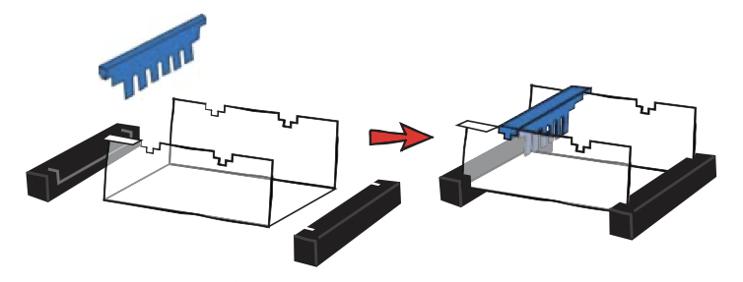

Figure 1: Assembly of an end well gel.

- Calculate the total volume of gel solution your group will need, depending on the number of gels you are making.
Total volume needed: __________ mL

PART II: DETERMINE AGAROSE PERCENTAGE

- A 2% agarose gel means:
2 grams of agarose per 100mL of buffer
Use the information above to calculate how much agarose and buffer your group needs for a 1% gel. Show your work by writing out your equation and calculations clearly:

- Confirm your final recipe:
Amount of agarose powder: _______ g
Amount of buffer (TG or TAE): _______mL
Have another group member check your math!

- Mix your agarose and buffer together in your microwave-safe container, such as a 125mL flask. Microwave until boiling and make sure all agarose has been dissolved.
- Pour molten agarose mixture into completed gel tray and let it cool until solidified. This should take approximately 10 minutes.

PART III: REFLECTION

- Did your gel solidify as expected? Why or why not?

- What would happen if too much or too little agarose is used?

- In what circumstances would you need to use an end well gel? What about a center well gel?

- How might changing the agarose percentage affect DNA or protein separation?

- If you wanted to make a 1.5% agarose gel using the same total volume, how many grams of agarose would you need?

Part II: Running a Gel
Agarose gel electrophoresis works by pulling charged molecules—both positive and negative—through a jelly-like matrix using an electric field. When the power is turned on, negatively charged molecules migrate toward the positive electrode, while positively charged molecules move toward the negative electrode. At the same time, the agarose gel acts like a sieve, slowing down larger or bulkier molecules more than smaller ones. Because of these combined effects, each molecule travels at a different rate, creating a distinct migration pattern.

During this investigation, you will prepare and load a series of dye samples into the gel, observe how each sample moves, and interpret the patterns that appear. Your goal is to determine the relative size and charge of each dye and then analyze an unknown mixture to figure out which dyes it contains.
Materials
- Samples 1 - 5 and X  - 1% Agarose Gel  - 1X TAE or TG Buffer | - Micropipette and tips  - Electrophoresis Chamber | - Power Source  - Colored pencils  - Small ruler

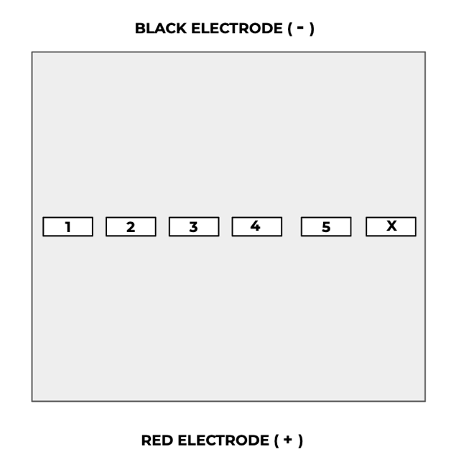

Sample Label | Dye Name | Charge  (- or +)
1 | Methyl Green
2 | Bromophenol Blue
3 | Xylene Cyanol
4 | Pyronin Y
5 | Safranin O
X | Unknown

PART I: SAMPLE PREPARATION

- Locate the practice dye in your colored tube rack. Along with your instructor, practice drawing up and expelling practice dye with your micropipette.
- Locate your six dye samples in your colored tube rack. Using your micropipette, load 10 uL of each sample into a separate well in your gel. Use the diagram below as a guide. Be sure to use a new pipette tip for each sample.
- Locate the electrophoresis box and place your gel into one of the six gel slots. The gel should be completely submerged in the electrophoresis buffer.
- Place the lid on the box, ensuring that the lid is correctly oriented to match the black and red electrodes.
- Run the gel at approximately 240 volts for around 10 minutes.
While your gel is running, answer the following questions:

- How can you tell your gel is running? ________________________________
- Is this a chemical or a physical change? ______________________________
- What is the purpose of the buffer? ___________________________________

PART II: ANALYZE YOUR RESULTS

- Using the diagram on the previous page, draw a picture to scale by measuring the distance traveled by the colored bands on your gel. Measurements are done from the leading edge of the well to the leading edge of the band.
- Which of the dyes traveled toward the positive electrode? Which traveled toward the negative electrode?
- What does this tell you about the charge of the dyes? Record the charge of each dye in the table on the previous page.
- Of the dyes that traveled toward the positive electrode, which was the largest molecule? Which was the smallest?

- Of the dyes that traveled toward the negative electrode, which was the largest molecule? Which was the smallest?

- Compare your known dyes (samples 1-5) with the unknown (sample X). Which dyes are present in the unknown?

- If you had a black and white image of your gel, would you still be able to tell which dyes were present in the unknown sample? How?

