While the promise of the CRISPR Cas9 system to permanently treat many diseases is very promising, it will require careful testing by researchers to ensure that their strategy does not lead to unwanted consequences. One of the most important steps in this procedure is identifying the Cas9 target site. If the correct site is not selected, it can lead to mutations in other parts of the genome that can lead to unintended and sometimes harmful outcomes.
To avoid these off-target effects, when researchers design their gRNAs they use databases such as BLAST from the National Center for Bioinformatics to ensure they are accurate and specific.
In this activity, we will look at a case study of using CRISPR to treat sickle cell anemia.
After this activity you should feel comfortable:
- Identifying Cas9 target sites
- Using genomic databases such as BLAST
Background
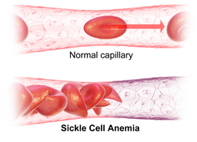
Sickle cell disease is an inherited blood disorder in which a person’s red blood cells become sickle- shaped, which increases the risk of blood clots. Approximately 100,000 people die of complications from sickle cell disease each year.

Sickle cell disease is caused by a single nucleotide polymorphism (SNP) in the hemoglobin B (HBB) gene called rs334. People homozygous for adenine at rs334 produce normal hemoglobin while those homozygous for thymine at rs334 produce sickling hemoglobin and have the disease.

Gene-Editing Therapy Strategy
The goal of gene-editing therapy for sickle cell disease is to allow expression of functional non-sickling hemoglobin. Red blood cells, which carry hemoglobin, are formed from hematopoietic stem cells in bone marrow. A potential gene-therapy strategy is to harvest hematopoietic stem cells from a patient, edit the HBB gene in those cells, and reintroduce them to the patient. CRISPR-based gene editing is used to replace thymine with adenine at rs334 by making a cut near the SNP and introducing the correct sequence using homology-directed recombination (HDR).

HBB gene sequence information
Gene Accession number: NG_059281.1
Gene Reference: Homo sapiens hemoglobin subunit beta (HBB),
RefSeqGene on chromosome 11
Gene Abbreviation: HBB

The sequence below is an excerpt of HBB, nucleotide position 5,053 to 5,106, with rs334 shown bolded and with an asterisk.
- Scan the provided DNA sequence and identify all 2-3 potential Cas9 target sequences.
  - A Cas9 target site includes a 20-nucleotide protospacer sequence followed downstream by an appropriate PAM sequence (5'-NGG) in the 5' to 3' direction.
  - The target sequence is 23 nucleotides long
  - Target sequences can be found on either DNA strand, but always in the 5' to 3' direction

Target Sequence Name (e.g HBB-1A) | # of 1st Nucleotide | # of Last Nucleotide | 23-Nucleotide Sequence (5’ – 3’)

- Perform BLAST Search for Off-Target Sequences
  - Go to blast.ncbi.nlm.nih.gov
  - Select Nucleotide BLAST
  - Enter your potential target sequence
  - Choose Search Set > Database, select Human RefSeqGene sequences
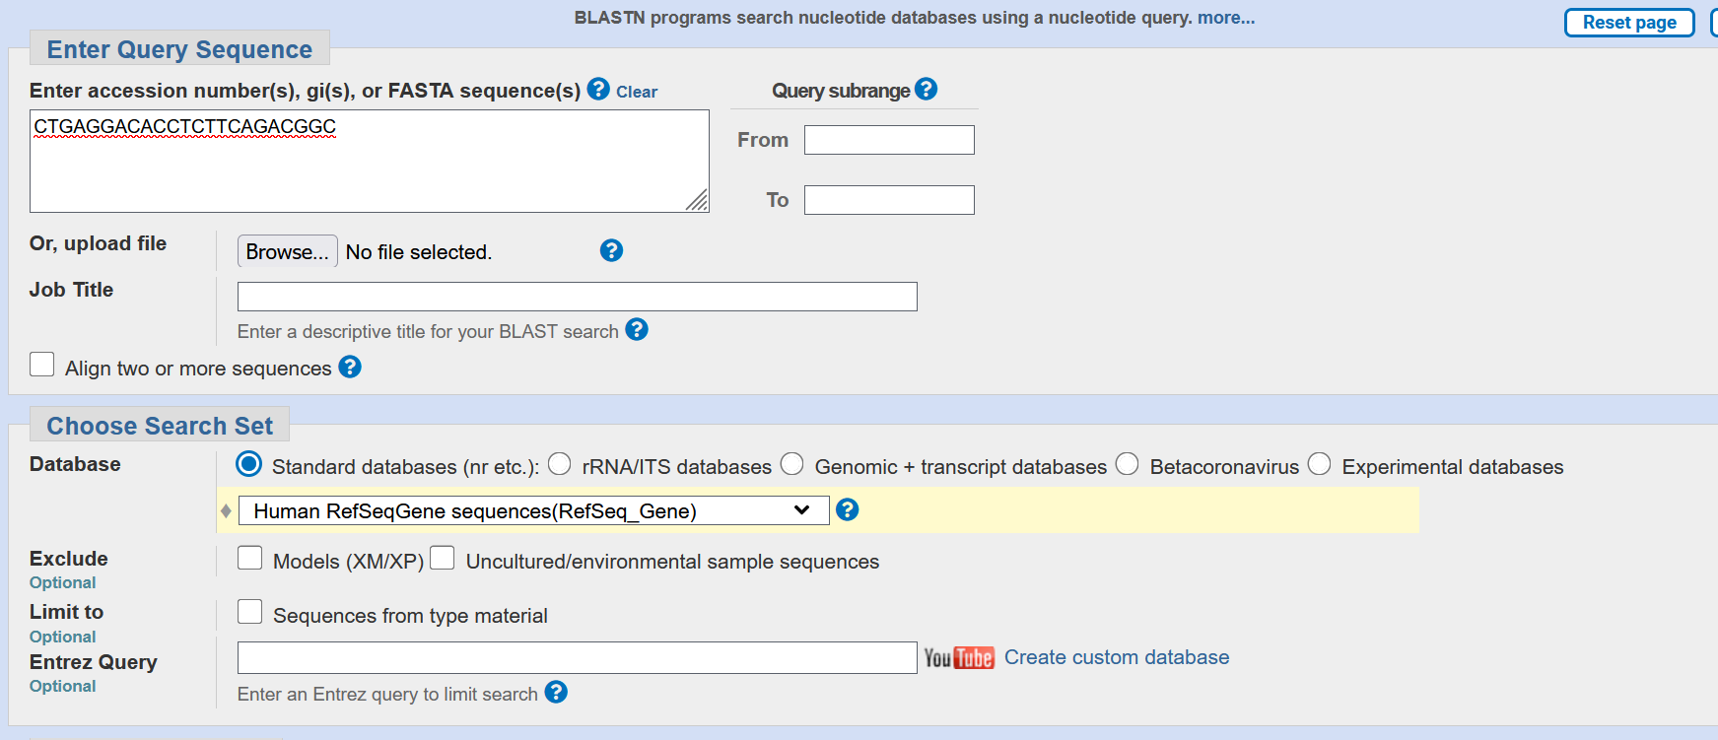
  - Choose to open results in new window and hit BLAST
- Review your results
  - Look at your results. Do you see the HBB gene you are researching? Click on it to see what information is provided. Write down your observations here

  - Go back and look at some of the other results that popped up. Write your observations here.

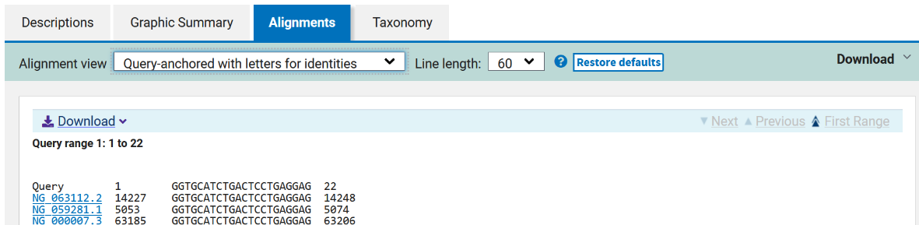

- One of the top results is your match for the gene. Click on the accession number and ensure it matches.
  - Your sequence (Query) appears at the top of the results for easy reference. The remaining rows display nucleotide sequences from genes that match or partially match your query sequence.
  - The links on the left are the accession numbers for reference genes. Each gene in the database has its own accession number.

- In your bioinformatics results table record 2-5 alignment results whose sequences include the PAM sequence 5’-NGG aligned with that of the query sequence, where N is any nucleotide. Use the accession number link to retrieve additional information to fill in the table. There may be multiple results for a single accession number

  - Highlight any exact alignment matches in genes other than your intended target.
  - Circle the longest alignment sequence(s) other than your intended target

- Repeat for each of your target sequences.

- Evaluate your target sites

Develop three criteria that could be used to rank the candidate target sites according to their safety for therapeutic use. Use the alignment results you have collected in your BLAST search as well as the information you considered from the readings and focus questions as you select criteria.

CRISPR BIOINFORMATICS CHART

