Using a Micropipette:
- Select a micropipette with a range appropriate for the volume you want to measure, just like you would choose the appropriately sized graduated cylinder for the volume you need.
- When adjusting the plunger to the correct volume, the plunger will change in height. The smaller the volume, the closer the plunger will be to the shaft of the device. Less air needs to be expelled to make room for small amounts of liquid.
- Add a micropipette tip to the end of the device. This allows one micropipette to be used with an infinite number of reagents without contamination.
- Follow the forward pipetting procedure (pictured) to pick up and dispel the liquid. This procedure utilizes the device’s two stops to accurately measure the necessary volume.
  - From resting to first stop dispels the exact amount of air to make room for the volume to which you have set the micropipette.
  - Returning from the first stop to resting, pulls the liquid up into the attached tip of the pipette.
  - Going from resting to second stop, a slightly larger volume is dispelled from the micropipette tip. This gives an extra bit of air to ensure that all the liquid is dispelled.
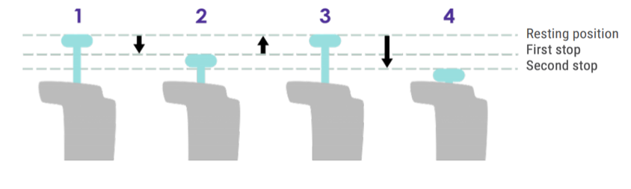

Materials:
- Micropipette (p50)
- Micropipette tips (5-200 μL)
- Micropipette (p1000)
- Micropipette tips (100-1,000 μL)
- Permanent Marker
- Six 1.5 ml microcentrifuge tubes

Procedure:
1. Label the six 0.5mL microcentrifuge at your station, 1-6.
2. Add 190 μL of Red Dyed Water into tube 1. This amount has been recorded in the table below for you.
3. Add 220 μL of Yellow Dyed Water into tube 3. Record this in the table below.
4. Add 250 μL of Blue Dyed Water into tube 5. Record this in the table below.
5. Take 40 μL from tube 1 and put it into tube 2. Record this in the table below.
6. Take 40 μL from tube 1 and put it into tube 6. Record this in the table below.
7. Take 40 μL from tube 3 and put it into tube 4. Record this in the table below.
8. Take 70 μL from tube 3 and put it into tube 2. Record this in the table below.
9. Take 70 μL from tube 5 and put it into tube 4. Record this in the table below.
10. Take 70 μL from tube 5 and put it into tube 6. Record this in the table below.
11. Use the data table to find the total volume in each tube and record the answer in the table.

Test Tube Number | Volume added or subtracted (μL) | Volume added or subtracted (μL) | Volume added or subtracted (μL) | Total Volume in microliters (μL) | Color
Tube 1
Tube 2
Tube 3
Tube 4
Tube 5
Tube 6

Accuracy Check:
Use the space below to discuss your results.
- Look at your samples and your final volumes. Do they match?
- Your tubes should contain the colors of the rainbow- Red, Orange, Yellow, Green, Blue, Violet. Have you made all the colors?
- Where do you think you had the most error?
________________________________________________________________________________________________________________________________________________________________________________________________________________________________________________________________________________________________________________________________________________________________________________________________________________________________________________________________

