The Trailer is a self-sufficient immersive learning pod on wheels. A modified trailer outfitted with technology and equipment; this mobile classroom accommodates up to 30 students. The Trailer is self-sufficient with its own electricity, heating, and cooling.

Trailer specifics
The trailer is a custom-built 73’ long, 25’ wide, and 14’ tall trailer. Along with the Semi that pulls it the total length of the trailer is 98’ long. The Trailer parking space needs to be at least 100’ long and 30’ wide on a hard, level surface (about 22 parking spaces 11x2). Entrance to the Trailer is located to the rear of the trailer including the wheelchair lift.

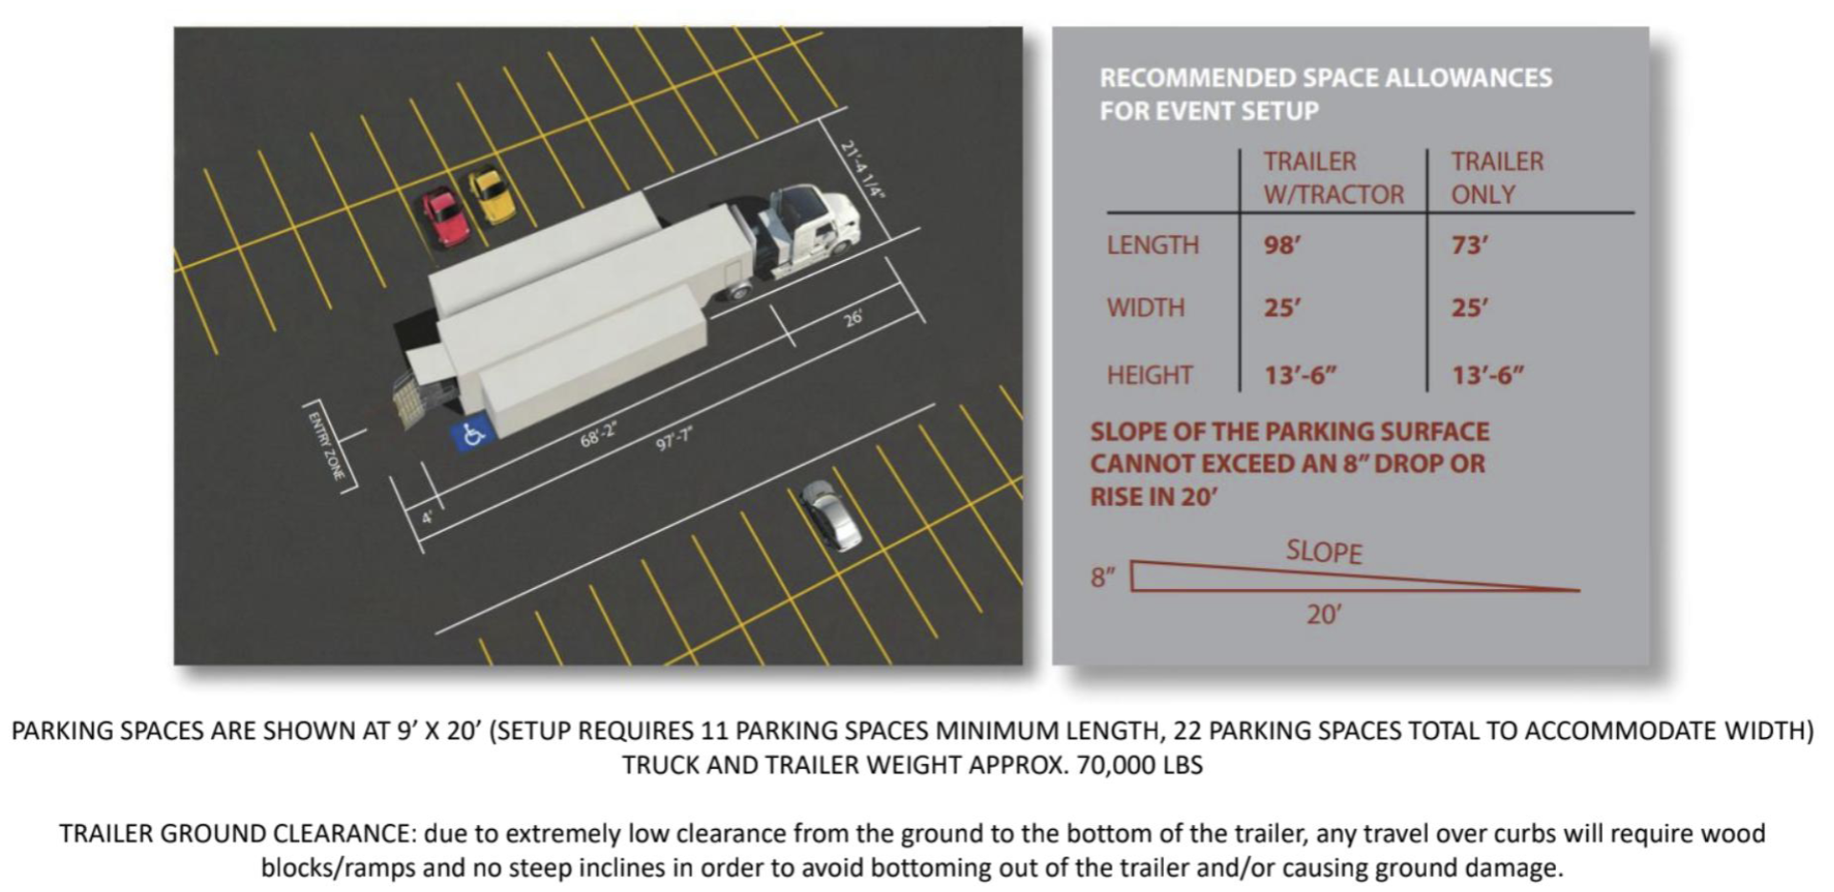

School Name:
Visit Date(s):
Primary Contact: |  | Cell Phone:
Email:
School Address:
Will the Trailer be parked inside a gate? | Yes No If yes, what are the operating hours of the gate?
Contact person on delivery date: |  | Cell Phone:
MRA Contacts: | Daniel Heuschele: Account Executive  Dan Ohnsman: Tour Manager | Cell Phone: | (248)-821-2241  (303)-809-1850

Choosing a space
- Be mindful of any low poles, power lines, and tree branches.
- The parking location should be easy to access, with no curbs or narrow turns.
- Please avoid a parking area that will disrupt the flow of your day-to-day operations.
- The contact person should be available during delivery, in case the driver has issues.
- The Trailer is transported by a semi-truck; please make sure the space allows for clearance of the semi.
- Please leave cones in the designated Trailer parking area the night before delivery.
- If the truck will be parked inside a gate, please provide Learning Undefeated staff with instructions to enter and exit as they please.

Parking Map
In the space below, please draw a map of the location where you want the Trailer placed, including any landmarks that will help the driver place the Trailer in its correct location.
Also, please attach a notated Google Map of the area or a photograph of the parking space highlighting the designated Trailer parking area.

